Optimal Intensity and Dose of Exercise to Improve University Students’ Mental Health: A Systematic Review and Network Meta-analysis of 48 Randomized Controlled Trials
Jihai Li¹, Zhidong Zhou², Sihai Hao¹, Liuhong Zang¹*
¹Institute of Physical Education, Xinjiang Normal University, Urumqi, Xinjiang, China
² School of Sports Science, Jishou University, Jishou, Hunan, China

*Corresponding author. Liuhong Zang, Institute of Physical Education, Xinjiang Normal University, Urumqi 830054, China.
Email address: zlh751225@126.com
Appendix 1. PRISMA NMA Checklist of Items to Include When Reporting A Systematic Review Involving a Network Meta-analysis
Section/Topic | Item # | Checklist Item | Reported on Page #
TITLE
Title | 1 | Identify the report as a systematic review incorporating a network meta-analysis (or related form of meta-analysis). | 0
ABSTRACT
Structured summary | 2 | Provide a structured summary including, as applicable:  Background: main objectives  Methods: data sources; study eligibility criteria, participants, and interventions; study appraisal; and synthesis methods, such as network meta-analysis.  Results: number of studies and participants identified; summary estimates with corresponding confidence/credible intervals; treatment rankings may also be discussed. Authors may choose to summarize pairwise comparisons against a chosen treatment included in their analyses for brevity.  Discussion/Conclusions: limitations; conclusions and implications of findings.  Other: primary source of funding; systematic review registration number with registry name. | 1
INTRODUCTION
Rationale | 3 | Describe the rationale for the review in the context of what is already known, including mention of why a network meta-analysis has been conducted. | 2-3
Objectives | 4 | Provide an explicit statement of questions being addressed, with reference to participants, interventions, comparisons, outcomes, and study design (PICOS). | 2-3
METHODS
Protocol and registration | 5 | Indicate whether a review protocol exists and if and where it can be accessed (e.g., Web address); and, if available, provide registration information, including registration number. | 3
Eligibility criteria | 6 | Specify study characteristics (e.g., PICOS, length of follow-up) and report characteristics (e.g., years considered, language, publication status) used as criteria for eligibility, giving rationale. Clearly describe eligible treatments included in the treatment network, and note whether any have been clustered or merged into the same node (with justification). | 3
Information sources | 7 | Describe all information sources (e.g., databases with dates of coverage, contact with study authors to identify additional studies) in the search and date last searched. | 3
Search | 8 | Present full electronic search strategy for at least one database, including any limits used, such that it could be repeated. | Appendix 2
Study selection | 9 | State the process for selecting studies (i.e., screening, eligibility, included in systematic review, and, if applicable, included in the meta-analysis). | 4-5
Data collection process | 10 | Describe method of data extraction from reports (e.g., piloted forms, independently, in duplicate) and any processes for obtaining and confirming data from investigators. | 4-7
Data items | 11 | List and define all variables for which data were sought (e.g., PICOS, funding sources) and any assumptions and simplifications made. | 3-4
Geometry of the network | S1 | Describe methods used to explore the geometry of the treatment network under study and potential biases related to it. This should include how the evidence base has been graphically summarized for presentation, and what characteristics were compiled and used to describe the evidence base to readers. | 5-7
Risk of bias within individual studies | 12 | Describe methods used for assessing risk of bias of individual studies (including specification of whether this was done at the study or outcome level), and how this information is to be used in any data synthesis. | 4-5
Summary measures | 13 | State the principal summary measures (e.g., risk ratio, difference in means). Also describe the use of additional summary measures assessed, such as treatment rankings and surface under the cumulative ranking curve (SUCRA) values, as well as modified approaches used to present summary findings from meta-analyses. | 5-7
Planned methods of analysis | 14 | Describe the methods of handling data and combining results of studies for each network meta-analysis. This should include, but not be limited to:  - Handling of multi-arm trials;  - Selection of variance structure;  - Selection of prior distributions in Bayesian analyses; and  - Assessment of model fit. | 5-7
Assessment of Inconsistency | S2 | Describe the statistical methods used to evaluate the agreement of direct and indirect evidence in the treatment network(s) studied. Describe efforts taken to address its presence when found. | 4-5
Risk of bias across studies | 15 | Specify any assessment of risk of bias that may affect the cumulative evidence (e.g., publication bias, selective reporting within studies). | 4-5
Additional analyses | 16 | Describe methods of additional analyses if done, indicating which were pre-specified. This may include, but not be limited to, the following:  - Sensitivity or subgroup analyses;  - Meta-regression analyses;  - Alternative formulations of the treatment network; and  - Use of alternative prior distributions for Bayesian analyses (if applicable). | 3-7
RESULTS†
Study selection | 17 | Give numbers of studies screened, assessed for eligibility, and included in the review, with reasons for exclusions at each stage, ideally with a flow diagram. | 7-8
Presentation of network structure | S3 | Provide a network graph of the included studies to enable visualization of the geometry of the treatment network. | Figure 2
Summary of network geometry | S4 | Provide a brief overview of characteristics of the treatment network. This may include commentary on the abundance of trials and randomized patients for the different interventions and pairwise comparisons in the network, gaps of evidence in the treatment network, and potential biases reflected by the network structure. | 7-8
Study characteristics | 18 | For each study, present characteristics for which data were extracted (e.g., study size, PICOS, follow-up period) and provide the citations. | 7-9
Risk of bias within studies | 19 | Present data on risk of bias of each study and, if available, any outcome level assessment. | 9-11
Results of individual studies | 20 | For all outcomes considered (benefits or harms), present, for each study: 1) simple summary data for each intervention group, and 2) effect estimates and confidence intervals. Modified approaches may be needed to deal with information from larger networks. | 9-12
Synthesis of results | 21 | Present results of each meta-analysis done, including confidence/credible intervals. In larger networks, authors may focus on comparisons versus a particular comparator (e.g. placebo or standard care), with full findings presented in an appendix. League tables and forest plots may be considered to summarize pairwise comparisons. If additional summary measures were explored (such as treatment rankings), these should also be presented. | 9-13
Exploration for inconsistency | S5 | Describe results from investigations of inconsistency. This may include such information as measures of model fit to compare consistency and inconsistency models, P values from statistical tests, or summary of inconsistency estimates from different parts of the treatment network. | 10-12
Risk of bias across studies | 22 | Present results of any assessment of risk of bias across studies for the evidence base being studied. | 12
Results of additional analyses | 23 | Give results of additional analyses, if done (e.g., sensitivity or subgroup analyses, meta-regression analyses, alternative network geometries studied, alternative choice of prior distributions for Bayesian analyses, and so forth). | 10-12
DISCUSSION
Summary of evidence | 24 | Summarize the main findings, including the strength of evidence for each main outcome; consider their relevance to key groups (e.g., healthcare providers, users, and policy-makers). | 14-16
Limitations | 25 | Discuss limitations at study and outcome level (e.g., risk of bias), and at review level (e.g., incomplete retrieval of identified research, reporting bias). Comment on the validity of the assumptions, such as transitivity and consistency. Comment on any concerns regarding network geometry (e.g., avoidance of certain comparisons). | 15-16
Conclusions | 26 | Provide a general interpretation of the results in the context of other evidence, and implications for future research. | 16-17
FUNDING
Funding | 27 | Describe sources of funding for the systematic review and other support (e.g., supply of data); role of funders for the systematic review. This should also include information regarding whether funding has been received from manufacturers of treatments in the network and/or whether some of the authors are content experts with professional conflicts of interest that could affect use of treatments in the network. | 17
PICOS = population, intervention, comparators, outcomes, study design.
* Text in italics indicate wording specific to reporting of network meta-analyses that has been added to guidance from the PRISMA statement.
† Authors may wish to plan for use of appendices to present all relevant information in full detail for items in this section.

Appendix 2. Search strategy.
Database | Search Terms
 | Exercise | College student | Mental health | Randomized controlled tria
PubMed  [Title/Abstract] | Exercise [MeSH Terms] OR exerci* OR sport* OR aerobic* OR physical exerci* OR physical activi* OR physical train* OR circuit training OR physical endurance OR physical fitness OR resistance training OR strength training | Students [MeSH Terms] OR student* AND Universities [MeSH Terms] OR undergrad* OR college* OR education OR tertiary* OR universit* | Mental Health [MeSH Terms] OR Mental Disorders [MeSH Terms] OR mental* OR anxiety OR depression OR wellbeing* OR stress* OR coping* OR loneli* OR social isolation OR distress* | randomized controlled trial OR randomized OR placebo OR RCT
Cochrane  [Title/Abstract/  keywords] | Exercise [MeSH Terms] OR exerci* OR sport* OR aerobic* OR physical exerci* OR physical activi* OR physical train* OR circuit training OR physical endurance OR physical fitness OR resistance training OR strength training | Students [MeSH Terms] OR student* AND Universities [MeSH Terms] OR undergrad* OR college* OR education OR tertiary* OR universit* | Mental Health [MeSH Terms] OR Mental Disorders [MeSH Terms] OR mental* OR anxiety OR depression OR wellbeing* OR stress* OR coping* OR loneli* OR social isolation OR distress* | randomized controlled trial OR randomized OR placebo OR RCT
Embase  [Title/Abstract] | Exercise [Emtree term] OR exerci* OR sport* OR aerobic* OR physical exerci* OR physical activi* OR physical train* OR circuit training OR physical endurance OR physical fitness OR resistance training OR strength training | Students [Emtree term] OR student* AND Universities [Emtree term] OR undergrad* OR college* OR education OR tertiary* OR universit* | Mental Health [Emtree term] OR Mental Disorders [Emtree term] OR mental* OR anxiety OR depression OR wellbeing* OR stress* OR coping* OR loneli* OR social isolation OR distress* | randomized controlled trial OR randomized OR placebo OR RCT
Web of Science  [Topic] | exercise OR exerci* OR sport* OR aerobic* OR physical exerci* OR physical activi* OR physical train* OR circuit training OR physical endurance OR physical fitness OR resistance training OR strength training | students OR student* AND universities OR undergrad* OR college* OR education OR tertiary* OR universit* | mental health OR mental disorders OR mental* OR anxiety OR depression OR wellbeing* OR stress* OR coping* OR loneli* OR social isolation OR distress* | randomized controlled trial OR randomized OR placebo OR RCT
EBSCO  [Abstract] | exercise OR exerci* OR sport* OR aerobic* OR physical exerci* OR physical activi* OR physical train* OR circuit training OR physical endurance OR physical fitness OR resistance training OR strength training | students OR student* AND universities OR undergrad* OR college* OR education OR tertiary* OR universit* | mental health OR mental disorders OR mental* OR anxiety OR depression OR wellbeing* OR stress* OR coping* OR loneli* OR social isolation OR distress* | randomized controlled trial OR randomized OR placebo OR RCT
CNKI  [Title/Abstract/  keywords] | exercise + physical exercise + physical training + circuit training + physical endurance + physical fitness + resistance training + strength training | students AND universities + education | mental health + mental disorders + anxiety + depression + social isolation + distress | randomized controlled trial + randomized + placebo + RCT
Wanfang  [Title/Abstract/  keywords] | exercise OR physical exercise OR physical training OR circuit training OR physical endurance OR physical fitness OR resistance training OR strength training | students AND universities OR education | mental health OR mental disorders OR anxiety OR depression OR social isolation OR distress | randomized controlled trial OR randomized OR placebo OR RCT
VIP  [Title/Abstract/  keywords] | exercise OR physical exercise OR physical training OR circuit training OR physical endurance OR physical fitness OR resistance training OR strength training | students AND universities OR education | mental health OR mental disorders OR anxiety OR depression OR social isolation OR distress | randomized controlled trial OR randomized OR placebo OR RCT

Appendix 3. Characteristics of the included studies
Author and published year | Country | Number  (Men/Female) | Age (mean [SD]) | Mental health status | Means of intervention | Intensity | Exercise duration  (minutes) | Period and frequency  (week×[times/week]) | Whether supervised | Measurement method | Outcomes
Akandere 2011 | Turkey | 60(30/30) | 20-24 | mild depression | dance | L | 110 | 10*3 | supervised | BDI | ①
 |  | 60(30/30) |  |  | maintain lifestyle
Alsaraireh 2017 | Jordan | 90 |  | moderate depression | AE+RT | M | 60 | 10*3 | supervised | CESD-R | ①
 |  | 91 |  |  | meditation | VL
Barğı 2022 | Turkey | 15(2/13) | 20±1.07 | moderate depression and anxiety | walk | M | 45 | 4*5 | supervised | BDI, BAI | ①②
 |  | 16(1/15) | 19.94±1.24 |  | maintain lifestyle
Cai 2019 | China | 233 F | 20.46±1.52 | milde depression and anxiety | Aerobics + dance + running | M | 60 | 16*3 | supervised | SCL-90 | ①②
 |  | 246 F | 20.62±1.65 |  | maintain lifestyle
Castellote 2024 | Spain | 65(33/32) | 20.29±1.78 | mild anxiety and moderate stress | hatha yoga | L | 60 | 12*2 | supervised | STAI, PSS | ②③
 |  | 64(30/34) | 20.30±1.76 |  | maintain lifestyle
Cheng 2016 | China | 15（7/8） | 21.1±1.4 | mild depression | wuqinxi | M | 40 | 12*3 | supervised | HAMD | ①
 |  | 15（8/7） | 21.1±1.4 |  | maintain lifestyle
de Lira 2023 | Brazil | 14 | 19.08± 0.6 | mild depression and poor quality of sleep | RT | M | 60 | 4*2 | supervised | POMS, HAD | ①②③
 |  | 7 | 20.0 ± 0.7 |  | maintain lifestyle
Dechamps 2008 | France | 11(5/6) | 23.6 ± 2.24 | mild anxiety and sedentary | Chen style tai chi chuan | M | 60 | 3.5/4 | supervised | POMS, STAI-Y | ①②
 |  | 12(3/9) | 22.6 ± 2.77 |  | maintain lifestyle
Dinani 2019 | Iran | 32 | 21.5 | mild depression, anxiety and stress | Yang's tai chi | M | 40 | 8*3 | supervised | DASS-42 | ①②③
 |  | 32 | 21.5 |  | maintain lifestyle
Eather 2018 | Australian | 27 | 20.23±1.72 | moderate stress | UNI-HIIT | V | 10 | 8*1 | supervised | STAI, PSS | ②③
 |  | 26 | 20.38±1.88 |  | maintain lifestyle
Falsafi 2016 | America | 23 | ＞18 | moderate depression and anxiety | Hatha yoga | L | 75 | 8*1 | supervised | BDI, HAM-A | ①②
 |  | 23 |  |  | maintain lifestyle
Gallego 2014 | Spain | 42 | 20.07±3.68 | healthy | sports games | L | 60 | 8*1 | supervised | DASS-21 | ①②③
 |  | 42 | 20.07±3.68 |  | maintain lifestyle
Ghorbani 2014 | Iran | 15 F | 26.06±1.18 | mild anxiety | running and rope skipping | V | 60 | 6*3 | supervised | GHQ-28 | ②
 |  | 15 F | 26.33±1.3 |  | maintain lifestyle
Herring 2011 | America | 10 F | 25.6±7.1 | mild or moderate depression | RT | V | 47 | 6*2 | supervised | ADIS-IV | ②
 |  | 10 F | 20.7±3 |  | AE | V
 |  | 10 F | 24.2±6.3 |  | maintain lifestyle
Hua2021 | China | 67(1/66) | 20.29±0.837 | mild anxiety | yoga | VL | 90 | 12*1 | supervised | DASS-21 | ①②③
 |  | 60(21/39) | 20.38±0.804 |  | tai chi | L
 |  | 20(10/10) | 21.15±1.04 |  | maintain lifestyle
Ji 2022 | China | 66(35/31) | 21.42±2.4 | mild anxiety | basketball | V | 60 | 6*2 | supervised | SAS | ②
 |  | 64(39/25) | 22.31±3.1 |  | running+RT | M | 45
 |  | 67(41/26) | 21.9±2.1 |  | maintain lifestyle
Jiao 2010 | China | 21(9/12) | 21.42 | healthy | AE | L | 30 | 8*3 | supervised | SDS | ①
 |  | 23(9/14) | 21.43 |  | maintain lifestyle
Jiao 2021 | China | 40 F | 20.0±1.3 | moderate depression and anxiety | wuqinxi | L | 80 | 16*5 | supervised | SCL-90 | ①②
 |  | 40 F | 20.0±1.3 |  | Volleyball and basketball | M
Kanojia 2013 | India | 25 F | 18.6±1.08 | mild depression | yoga | VL | 40 | 12*6 | supervised | SRC | ①②
 |  | 25 F | 18.08±0.759 |  | maintain lifestyle
Kim 2012 | Korea | 7 | 24.83±9.41 | moderate anxiety | Kouk Sun Do (KSD), | VL | 70 | 4*3 | supervised | BDI-II, STAI | ①②
 |  | 11 | 24.83±9.41 |  | maintain lifestyle
Kim 2014 | Korea | 12 F | 21.0 ± 0.2 | Mild stress | yoga nidra | VL | 60 | 12*1 | supervised | LSSCS | ③
 |  | 15 F | 21.0 ± 0.3 |  | maintain lifestyle
Li 2008 | China | 20 F | 20.35±0.88 | sedentary | tai chi | VL | 60 | 8*3 | supervised | POMS | ①
 |  | 18 F | 20.35±0.88 |  | non–exercise
Li 2015 | China | 101(15/86) | 20.63±1.03 | healthy | baduanjin | M | 60 | 12*5 | supervised | PSS | ③
 |  | 105(21/84) | 20.92±1.15 |  | maintain lifestyle
Li 2022 | China | 13 F | 22.6 ± 2.5 | mild or moderate anxiety | RT | V | 50 | 8*2 | supervised | SAS | ②
 |  | 14 F | 22.5 ± 2.0 |  | maintain lifestyle
Li 2023 | China | 24 F | 18-26 | moderate depression | wuqinxi+meditation | L | 50 | 12*7 | supervised | HAMD, SCL-90 | ①②
 |  | 24 F | 18-26 |  | mental intervention
Lopez 2016 | Spain | 42(10/32) | 22.45 ± 4.96 | mild depression and anxiety | dance | V | 90 | 4*4 | supervised | CESD, PSS | ①③
 |  | 53(14/39) | 21.77 ± 4.53 |  | maintain lifestyle
Ma 2017 | China | 31 | 21. 43±1. 46 | mild depression and anxiety | basketball | M | 50 | 12*3 | supervised | SDS, SAS | ①②
 |  | 31 | 21. 43±1. 46 |  | maintain lifestyle
Murray 2022 | America | 46 F | 23.02 | mild depression and anxiety | AE+RT | M | 30 | 8*2 | supervised | MDI, GAD-7 | ①②
 |  | 28 F | 24.31 | mild depression and anxiety | yoga | VL
Paolucci 2018 | Canada | 19(6/13) | 21±3 | mild depression, anxiety and stress | MCT  (RPE=11) | L | 27.5 | 6*3 | supervised | BDI-II, BAI, PSS | ①②③
 |  | 18(5/13) | 21±4 |  | maintain lifestyle
Philippot 2022 | Belgium | 13(2/11) | 20.69 ±1.44 | mild depression and anxiety | HIIT(HRmax＞80%) | V | 10 | 4*3 | supervised | DASS-21 | ①②③
 |  | 15(1/14) | 20.93 ±1.94 |  | maintain lifestyle
Roth 1987 | America | 18(9/9) | 18.9±1.3 | mild depression and anxiety | running(75%Hrmax) | M | 30 | 11*3 | supervised | BDI, STAI | ①②
 |  | 19(10/9) | 18.9±1.3 |  | relaxation training | VL
 |  | 18(8/10) | 18.9±1.3 |  | maintain lifestyle
Sadeghi 2016 | Iran | 16(13/3) | 20.93±1.06 | mild or moderate depression | running(60-80%Hrmax) | V | 60 | 8*2 | supervised | BDI-II | ①
 |  | 14(11/3) | 20.92±1.20 |  | maintain lifestyle
Saltan 2020 | Turkey | 29(6/23) | 18.82 ± 1.071 | mild depression | Pilates | L |  | 12*3 | supervised | BDI | ①
 |  | 28(7/21) | 18.85 ± 2.495 |  | AE+RT | M
 |  | 35(4/31) | 19.42 ± 1.378 |  | maintain lifestyle
Sandre 2023 | Canada | 25(5/20) | 23.1±4 | mild depression and anxiety | AE+RT | V | 45 | 2*3 | supervised | BDI-II, HADS | ①②
 |  | 24(4/19) | 23.1±4 |  | maintain lifestyle
Schmalzl 2018 | America | 22(10/12) | 24.91±5.99 | Moderate stress | yoga(movemente) | L | 45 | 8*2 | supervised | PSS | ③
 |  | 18(7/11) | 23.94±5.41 |  | yoga(breath) | VL
Smits 2008 | America | 19(2/17) | 19.53±0.35 | Mild depression, anxiety and sedentary | running(70%Hrmax) | M | 25 | 2*3 | supervised | BDI, BAI | ①②
 |  | 20(7/13) | 22.65±2.09 |  | maintain lifestyle
Sun 2022 | China | 30(15/15) | 22 ± 1.5 | healthy | tai chi | L | 60 | 16*2 | supervised | SCL-90 | ①②
 |  | 30(15/15) | 22 ± 1.5 |  | non–exercise
Tang 2009 | China | 31 |  | mild depression and anxiety | yoga,aerobics | L | 60 | 12*3 | supervised | SDS | ①
 |  | 39 |  |  | maintain lifestyle
wang 2023 | China | 24(7/15) | 19.91±1.57 | mild depression and anxiety | HIIT | V | 40 | 8*3 | supervised | SCL-90 | ①②
 |  | 25(8/17) | 19.59±1.53 | mild depression and anxiety | AE+RT | M
Williams 1986 | America | 266 |  | mild or moderate depression | AE(60-70%Hrmax) | M | 50 | 10*3 | supervised | POMS | ①
 |  | 40 |  |  | maintain lifestyle
Xiao 2021 | China | 31(24/7) | 19.21±1.02 | mild anxiety and stress | baduanjin | L | 90 | 12*3 | supervised | SAS/PSS | ②③
 |  | 31(23/8) | 18.95 ± 0.89 | mild anxiety and stress | basketball | M
 |  | 34(24/10) | 19.71±1.77 |  | maintain lifestyle | M
Yunus 2020 | Malaysia | 18(4/14) | 22.67±1.138 | mild anxiety | Kinect Sports | L | 30 | 6*3 | supervised | (DASS)-21 | ①②③
 |  | 18(1/17) | 23.11±0.963 |  | maintain lifestyle
Zhang 2018 | China | 32 | 18.41±2.01 | mild depression | MTCC | L | 90 | 8*2 | supervised | PHQ-9, PSS | ①③
 |  | 30 | 18.41±2.01 |  | maintain lifestyle
Zhang 2024 | China | 30(12/18) | 20.1±0.759 | PMPU and sedentary | tai chi | L | 60 | 8*3 | supervised | SDS, SAS | ①②
 |  | 30(12/18) | 20.03±0.556 | PMPU and sedentary | AE | M
 |  | 30(12/18) | 20.2±0.61 |  | maintain lifestyle
Zhang JW 2023 | China | 9(2/7) | 24.20 ± 4.07 | mild anxiety or depression | tai chi | L | 60 | 8*5 | supervised | SAS | ②
 |  | 9(3/6) | 22.50 ± 5.95 |  | maintain lifestyle
Zhang YQ 2023 | China | 34 | 19.23± 0.98 | healthy | baduanjin | L | 60 | 12*3 | supervised | SCL-90 | ①②
 |  | 39 | 19.16±1.05 |  | maintain lifestyle
Zhao 2023 | China | 29(9/20) | 21.66±1.97 | mild or moderate depression | RT (60-90%HRR) | V | 30 | 12*3 | supervised | SDS | ①
 |  | 28(8/20) | 21.21±2.25 |  | maintain lifestyle
Zheng 2015 | China | 95(33/62) | 20.7±1.1 | mild stress | tai chi | M | 60 | 12*5 | supervised | PSS | ③
 |  | 103(32/71) | 20.6±1.2 |  | maintain lifestyle
M: Male, F: Female, VL: Very Light, L: Light, M: Moderate; V: Vigorous; BDI: Beck Depression Inventory, BAI: Beck Anxiety Inventory; CESD: Center for Epidemiologic Studies Depression Scale; SCL-90: Symptom Checklist 90; STAI: State-Trait Anxiety Inventory; PSS: Perceived Stress Scale; HAMD: Hamilton Rating Scale for Depression; POMS: Profile of Mood States; HAD: Hospital Anxiety and Depression Scale; DASS: Depression Anxiety Stress Scales; HAM: Hamilton Anxiety Rating Scale; GHQ: General Health Questionnaire; ADIS: Anxiety Disorders Interview Schedule; SAS: Self-Rating Anxiety Scale; SRC: Self report scale; LSSCS: Life Stress Scale for College Students; MDI: Major Depressive Inventory; GAD: Generalized Anxiety Disorder 7-item Scale ; ①: Depression;②: Anxiety;③: Stress.

Appendix 4. Risk of bias assessment.
Study | Allocation generation | Concealment of allocation | Blinding of outcome assessment | Dropout rate % | Selective reporting | Other bias | Risk category
Akandere 2011 | Low | Unclear | Unclear | 0% | Low | Low | Low
Alsaraireh 2017 | Low | Low | Unclear | 0% | Low | Low | Low
Barğı 2022 | Low | Low | Low | 0% | Low | Low | Low
Cai 2019 | Low | Low | Unclear | 0% | Low | Low | Low
Castellote 2024 | Low | Low | Low | 0% | Low | Low | Low
Cheng 2016 | Low | Unclear | Unclear | 0% | Low | Low | Low
de Lira 2023 | Low | Low | Unclear | 30% | Low | High | High
Dechamps 2008 | Low | Unclear | Unclear | 8% | Low | Low | Low
Dinani 2019 | Low | Low | Unclear | Unclear | Low | Low | Low
Eather 2018 | Low | Low | Low | Unclear | Low | Low | Low
Falsafi 2016 | Low | Unclear | Unclear | 25% | Low | Low | Moderate
Gallego 2014 | Low | Unclear | Unclear | 0% | Low | Low | Low
Ghorbani 2014 | Low | Low | Unclear | 0% | Low | Low | Low
Herring 2011 | Low | Low | Low | 0% | Unclear | Low | Low
Hua2021 | Low | Unclear | Unclear | 1% | Low | Low | Low
Ji 2022 | Low | Unclear | Unclear | 16% | Low | Low | Low
Jiao 2010 | Low | Low | Low | Unclear | Low | Low | Low
Jiao 2021 | Low | Unclear | Unclear | 0% | Low | Low | Low
Kanojia 2013 | Low | Unclear | Unclear | 0% | Low | Low | Low
Kim 2012 | Low | Low | Unclear | Unclear | Low | High | Moderate
Kim 2014 | Low | Low | Unclear | 0% | Low | Low | Low
Li 2008 | Low | High | Unclear | 0% | Low | Unclear | Moderate
Li 2015 | Low | Low | Low | 7% | Low | Low | Low
Li 2022 | Low | Low | Unclear | 0% | Low | Low | Low
Li 2023 | Low | Low | Unclear | 0% | Low | Low | Low
Lopez 2016 | Low | Unclear | Unclear | 21% | Unclear | Low | Moderate
Ma 2017 | Low | Unclear | Unclear | Unclear | Low | Low | Low
Murray 2022 | Low | Unclear | Unclear | 4% | Low | Low | Low
Paolucci 2018 | Low | Unclear | Unclear | 10% | Low | Low | Low
Philippot 2022 | Low | Low | Low | 7% | Low | Low | Low
Roth 1987 | Low | Unclear | Unclear | 0% | Low | Low | Low
Sadeghi 2016 | Unclear | Unclear | Unclear | Unclear | Low | Low | Moderate
Saltan 2020 | Low | Low | Low | 12% | Low | Low | Low
Sandre 2023 | Low | Unclear | Unclear | Unclear | Low | Low | Low
Schmalzl 2018 | Low | Unclear | Unclear | 37% | Low | Unclear | Moderate
Smits 2008 | Low | Low | High | 5% | Low | Unclear | Moderate
Sun 2022 | Low | Unclear | Unclear | 0% | Unclear | Low | Low
Tang 2009 | Low | Unclear | Unclear | 13% | Low | Low | Low
wang 2023 | Low | Low | Low | 3% | Low | Low | Low
Williams 1986 | Unclear | Unclear | Unclear | 0% | Low | Unclear | Moderate
Xiao 2021 | Low | Unclear | Unclear | 4% | Low | Low | Low
Yunus 2020 | Low | Low | Low | 0% | Low | Low | Low
Zhang 2018 | Low | Low | Low | 3% | Low | Low | Low
Zhang 2024 | Low | Low | Low | 0% | Low | Low | Low
Zhang JW 2023 | Low | Low | Low | 0% | Low | High | Moderate
Zhang YQ 2023 | Low | Low | Low | 6% | Low | Low | Low
Zhao 2023 | Low | Low | Low | 1% | Low | Low | Low
Zheng 2015 | Low | Low | Low | 4% | Low | Low | Low
Appendix 5. Forest plots for each pairwise comparison of sleep quality.

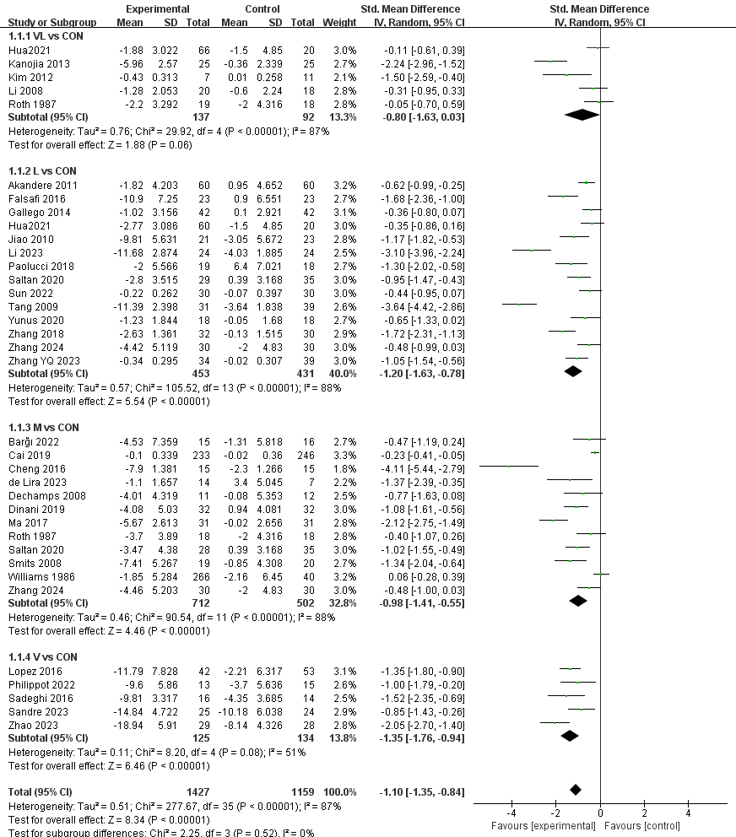
Appendix 5-1 forest plot of depression.
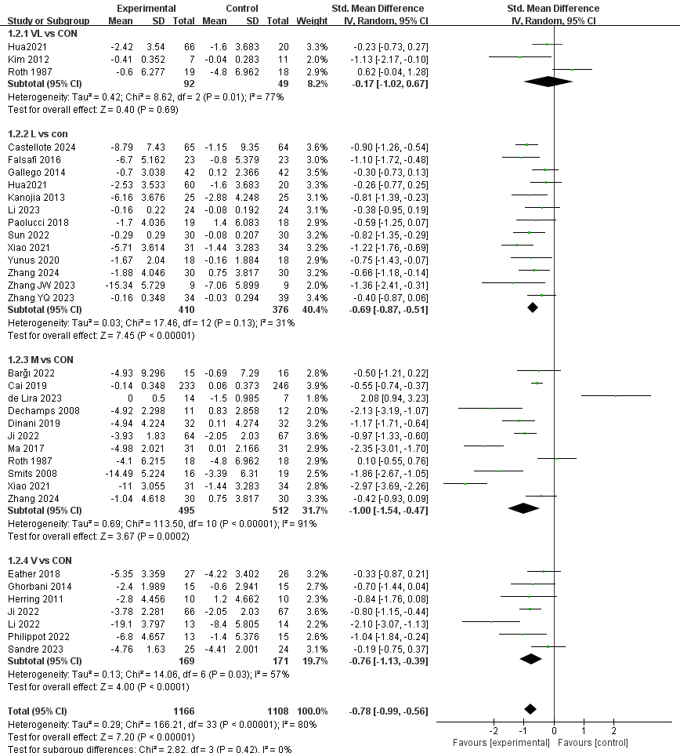
Appendix 5-2 forest plot of anxiety.

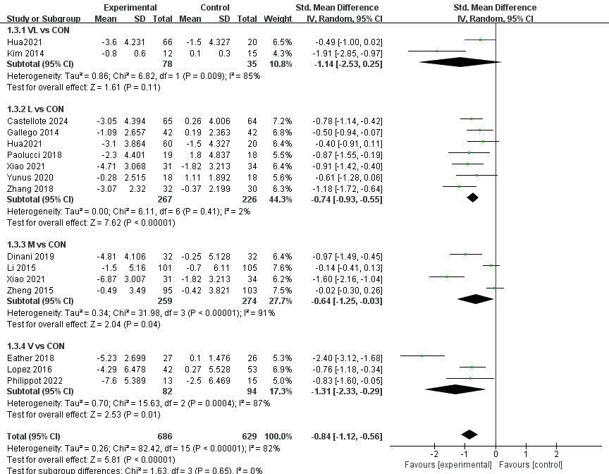
Appendix 5-3 forest plot of stress.

Appendix 6. Funnel plot of depression, anxiety and stress in pairwise meta-analysis.

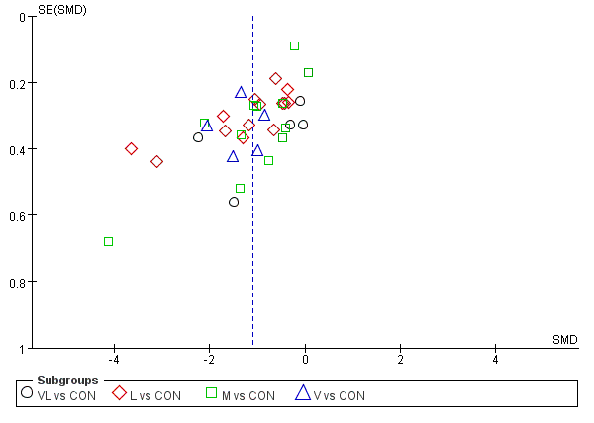
Appendix 6- 1 funnel plot of depression.

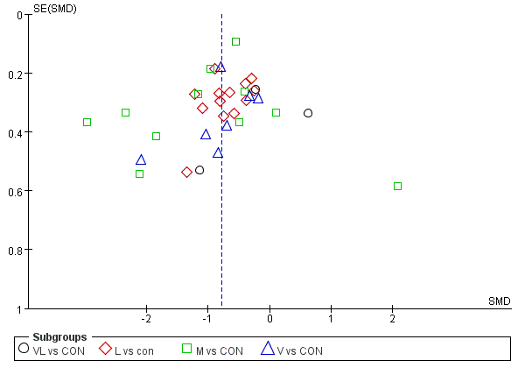
Appendix 6- 2 funnel plot of anxiety.

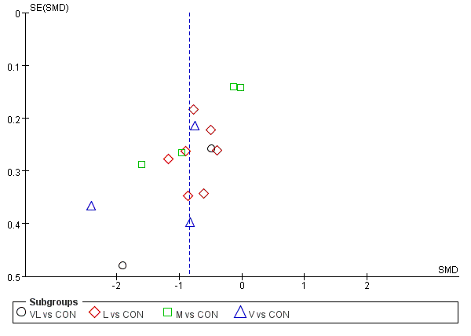
Appendix 6- 3 funnel plot of stress.
Appendix 7. Contributions of direct and indirect comparisons to NMA and the number of studies of each direct comparison of depression, anxiety and stress.

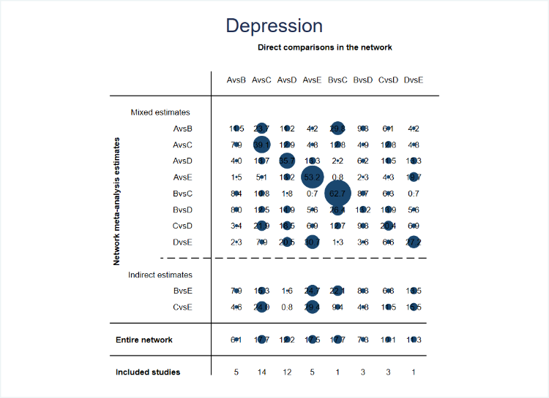
Appendix 7-1 depression.
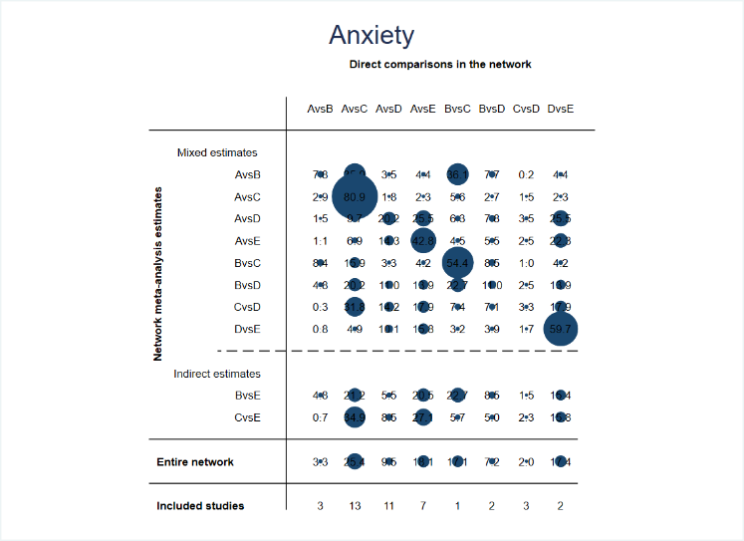
Appendix 7-2 anxiety.

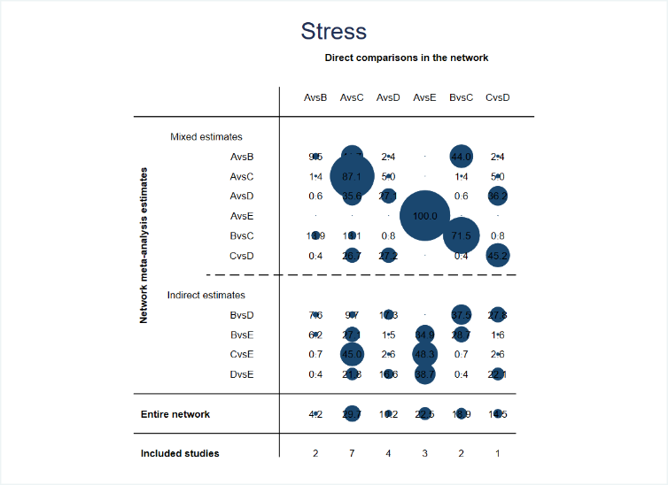
Appendix 7-3 stress.

Appendix 8. Inconsistency of depression, anxiety and stress tested by loop-specific heterogeneity estimates, inconsistency model and node splitting analysis.
Note: A-CON, B-VL, C-L, D-M, E-V
loop-specific heterogeneity estimates
Loop | IF | seIF | z_value | p_value | CI_95 | Loop_Heterog_tau2
Depression
CON-VL-M | 0.289 | 0.752 | 0.385 | 0.701 | (0.00,1.76) | 0.525
CON-VL-L | 0.208 | 1.076 | 0.194 | 0.846 | (0.00,2.32) | 0.621
CON-M-V | 0.199 | 0.958 | 0.208 | 0.835 | (0.00,2.08) | 0.397
VL-L-M | 0.1 | 0.791 | 0.126 | 0.899 | (0.00,1.65) | 0.331
CON-L-M | 0.087 | 0.678 | 0.128 | 0.898 | (0.00,1.42) | 0.522
Anxiety
CON-VL-M | 0.797 | 1.141 | 0.698 | 0.485 | (0.00,3.03) | 0.651
CON-VL-L | 0.616 | 0.437 | 1.41 | 0.159 | (0.00,1.47) | 0.07
VL-L-M | 0.167 | 1.33 | 0.126 | 0.9 | (0.00,2.77) | 0.905
CON-M-V | 0.071 | 0.902 | 0.078 | 0.938 | (0.00,1.84) | 0.594
CON-L-M | 0.068 | 0.662 | 0.103 | 0.918 | (0.00,1.37) | 0.462
Stress
CON-L-M | 0.789 | 0.619 | 1.275 | 0.202 | (0.00,2.00) | 0.198
CON-VL-L | 0.255 | 0.455 | 0.56 | 0.575 | (0.00,1.15) | 0.07

Inconsistency model
 | Depression | Anxiety | Stress
chi2 | 4.44 | 6 | 9.57
Prob > chi2 | 0.8798 | 0.8731 | 0.0885

Node splitting analysis
Side | Direct |  | Indirect |  | Difference
 | Coef. | Std. Err. | Coef. | Std. Err. | Coef. | Std. Err. | P>|z|
Depression
A B | -0.7959 | 0.391104 | -1.35396 | 0.561974 | 0.558061 | 0.685926 | 0.416
A C | -1.20165 | 0.227666 | -1.74209 | 0.680042 | 0.540443 | 0.717231 | 0.451
A D | -1.01067 | 0.253111 | -0.95409 | 0.453961 | -0.05658 | 0.519116 | 0.913
A E | -1.35335 | 0.388971 | -1.589 | 0.881942 | 0.235655 | 0.963903 | 0.807
B C | -0.26607 | 0.821433 | -0.28071 | 0.41351 | 0.01464 | 0.919715 | 0.987
B D | 0.023203 | 0.484132 | -0.05788 | 0.477167 | 0.081081 | 0.679772 | 0.905
C D | 0.202174 | 0.484491 | 0.289177 | 0.345923 | -0.087 | 0.595288 | 0.884
D E | -0.57876 | 0.852053 | -0.34306 | 0.450699 | -0.2357 | 0.963911 | 0.807
Anxiety
A B | -0.16726 | 0.434923 | -1.33646 | 0.591041 | 1.169206 | 0.737676 | 0.113
A C | -0.71702 | 0.210173 | -0.80912 | 0.625165 | 0.092098 | 0.660679 | 0.889
A D | -0.99695 | 0.231226 | -0.6521 | 0.431857 | -0.34486 | 0.490005 | 0.482
A E | -0.81754 | 0.2969 | -0.79119 | 0.7044 | -0.02636 | 0.764535 | 0.972
B C | -0.0315 | 0.720483 | -0.19531 | 0.470881 | 0.163818 | 0.860858 | 0.849
B D | -0.11521 | 0.528842 | -0.56628 | 0.530662 | 0.451071 | 0.7492 | 0.547
C D | -0.23705 | 0.429404 | -0.16888 | 0.324147 | -0.06817 | 0.538095 | 0.899
D E | 0.108655 | 0.520714 | 0.105357 | 0.393863 | 0.003297 | 0.652927 | 0.996
Stress
A B | -1.09813 | 0.472495 | -0.41302 | 0.629532 | -0.68511 | 0.793273 | 0.388
A C | -0.7481 | 0.240162 | -0.91483 | 0.796232 | 0.166728 | 0.831829 | 0.841
A D* | -0.64071 | 0.301316 | -1.41577 | 1.177518 | 0.775054 | 1.21496 | 0.524
B C | -0.16388 | 0.428317 | 0.725999 | 0.681474 | -0.88988 | 0.805748 | 0.269
C D | -0.67899 | 0.562068 | 0.422776 | 0.378728 | -1.10177 | 0.677112 | 0.104
* All the evidence about these contrasts comes from the trials which directly compare them.
Appendix 9. Forest plots of eligible comparisons of depression, anxiety and stress.

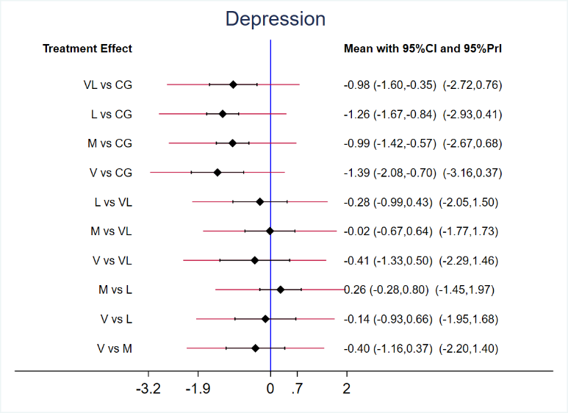
Appendix 9-1 depression.
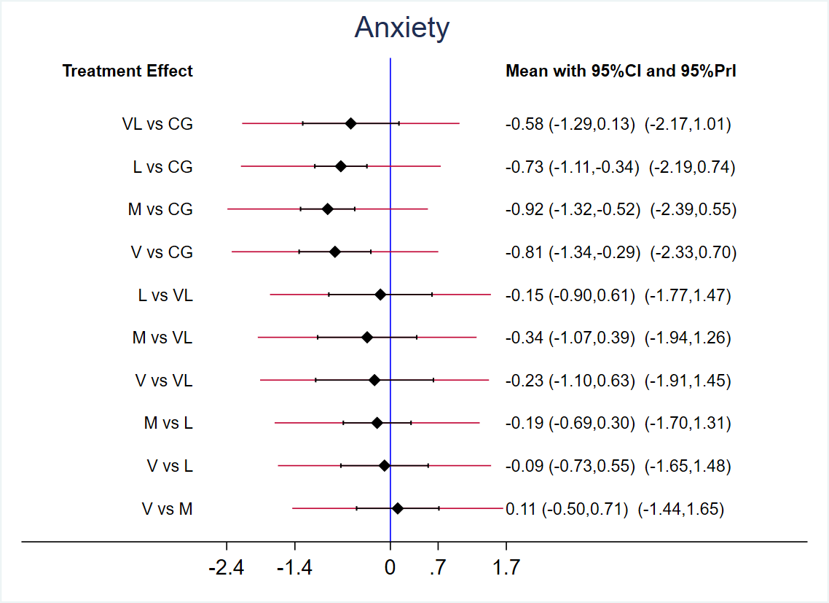
Appendix 9-2 anxiety.

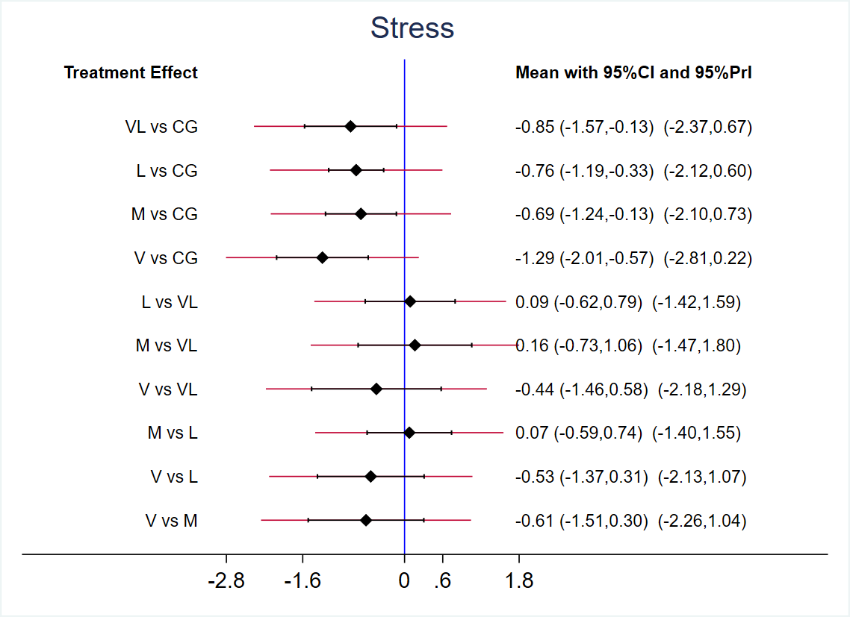
Appendix 9-3 stress.

Appendix 10. The funnel plot graphics of depression, anxiety and stress in NMA.
Note: A-CON, B-VL, C-L, D-M, E-V

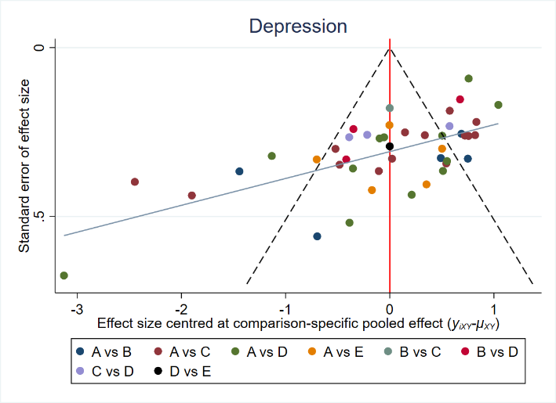
Appendix 10-1 depression.

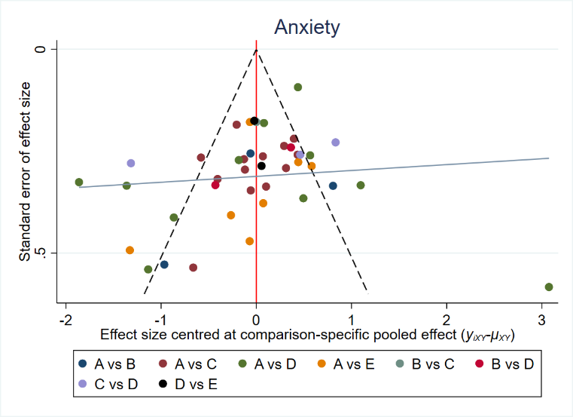
Appendix 10-2 anxiety.

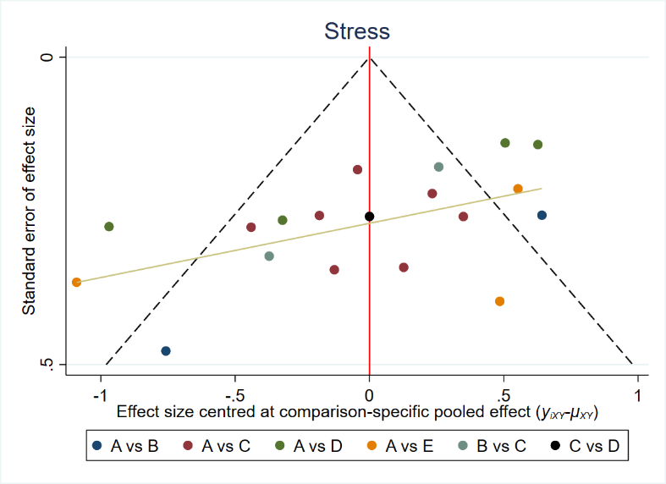
Appendix 10-3 stress.

Appendix 11. Area under the curve for cumulative ranking probability of each intervention on depression, anxiety and stress.

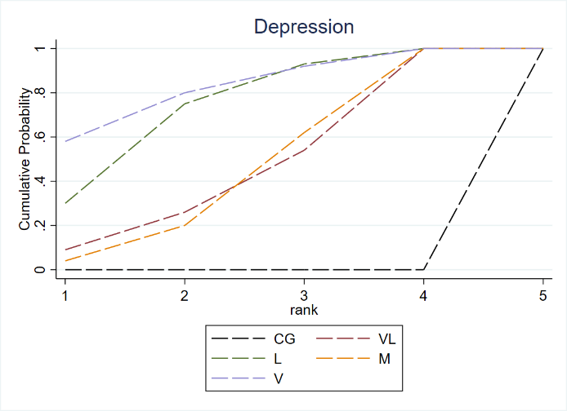
Appendix 11-1 depression.
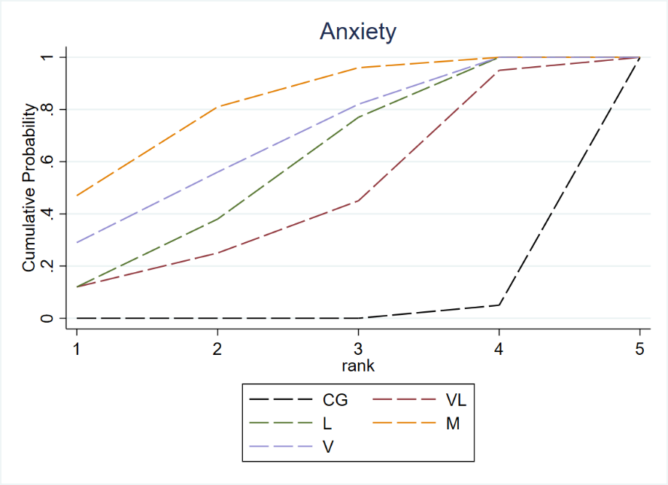
Appendix 11-2 anxiety.

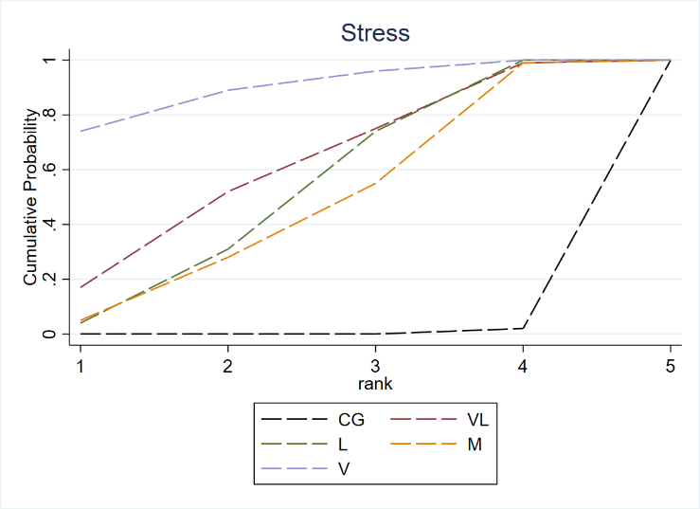
Appendix 11-3 stress.

Appendix 12. Key assumptions of Network Meta-Analysis
There are three key assumptions to conduct a Network Meta-Analysis (NMA): (1) network connectivity, (2) consistency in the data, and (3) transitivity(Donegan et al., 2013; Watt et al., 2019).
1.Connectivity
Connectivity is a key assumption in NMA which if deemed insufficient (i.e., due to lack of direct comparators) can lead to low statistical power and misleading results(Ter Veer et al., 2019). In our study, we assessed connectivity of the network at both treatment and agent levels visually and found no evidence of unconnectedness on either network (Appendix 12-1 and Appendix 12-2).

Appendix 12-1 Treatment-level network.

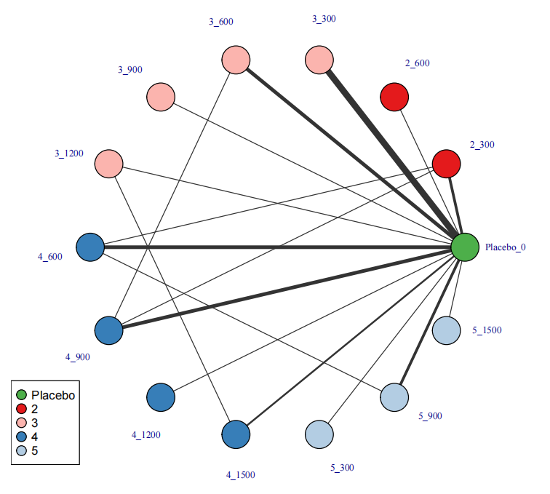

Appendix 12-2 Exercise intensity network.

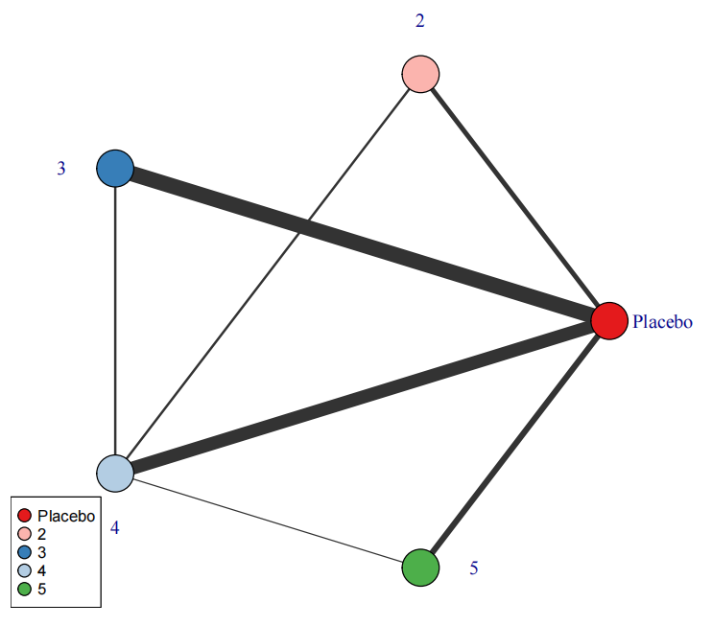
The first value indicates the specific intervention and the second one is the corresponding dose of that intervention (METs-min per week).
Placebo: control; 2: Very light; 3: Light; 4: Moderate; 5: Vigorous

2.Consistency
We carried out consistency analysis in the data through the comparison of consistent (i.e., network effect sizes) and unrelated mean effects (UME) models (i.e., pairwise effect sizes) of the network.
In practice, we checked whether deviance, the number of estimated parameters in the network, and the Deviance Informative Criterion (DIC) indicators were similar for both models which would indicate a good fit(Wheeler et al., 2010). Comparison of these parameters indicated good consistency across models (Appendix 12-3).

Appendix 12-3 Consistent and UME models fit comparison
Model | pD | Residual deviance | DIC | SD
Consistent | 67.9 | 69.687 | 171.8 | 0.184
UME | 67.4 | 69.909 | 171.2 | 0.156
pD: Number of estimated parameters; DIC: Deviance Informative Criterion; SD: Standard Deviation; UME: Unrelated Mean Effects. Scientific literature indicated that the main indicator to assess the model fit is the DIC. As lower DIC, better fit.

Transitivity
We assessed transitivity via MBNMA node-splitting approach. This method splits and compares contributions for a particular treatment contrast into direct and indirect evidence(van Valkenhoef et al., 2016). Similar effects denote good transitivity. Appendix 12-4 (density plots) below present the results for transitivity in this meta-analysis.

Appendix 12-4 Node-splitting analysis (density plot).
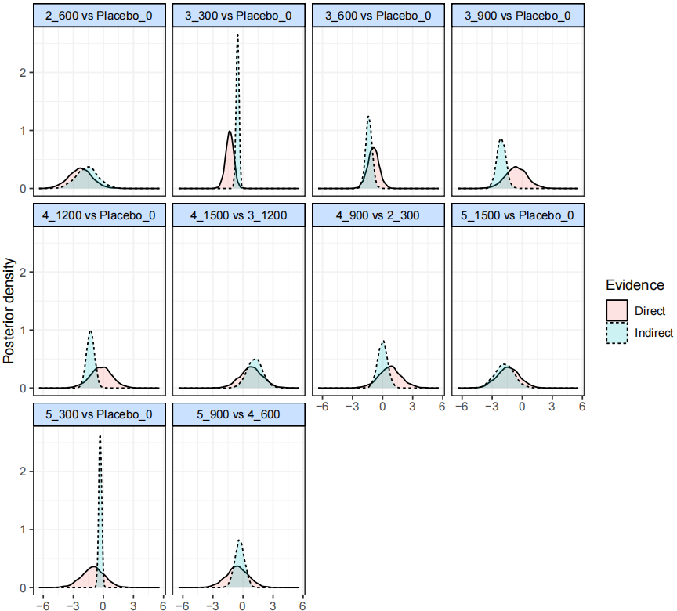
Note：The value of title is the corresponding dose of exercise intensity. CrI, credible interval.
2: Very light; 3: Light; 4: Moderate; 5: Vigorous.

Appendix 13 Models’ selection
1.Non-linear functions and models fit comparison
A meta-analysis (i.e., a "split" NMA) of the different doses of physical activity as separate and unrelated treatments were performed. This step helps determine which function is more appropriate for the data and should be used in a model-based network meta-analysis (MBNMA)(Mawdsley et al., 2016). Appendix 13-1 and Appendix 13-2 show the different result of each dose to overall and different intensity of exercise, respectively.
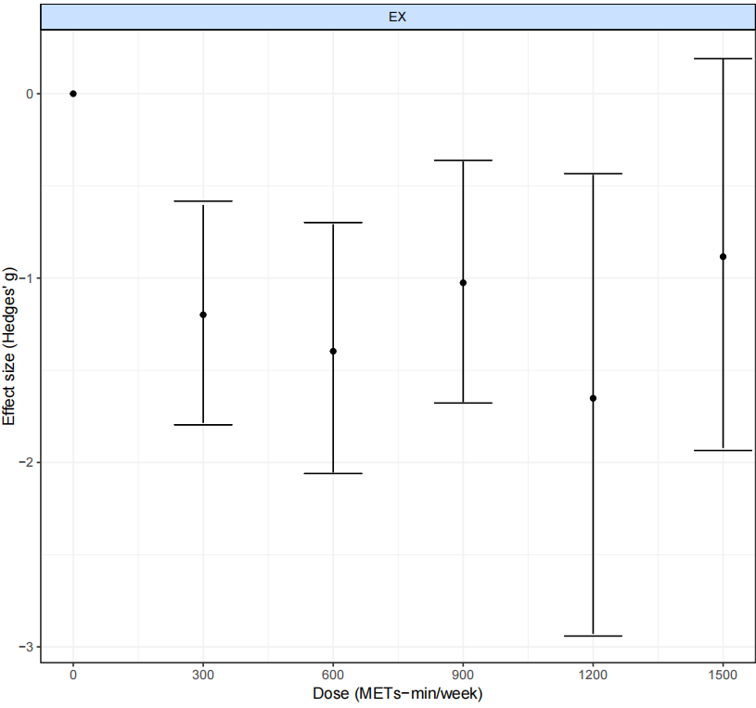
Appendix 13-1 “Split” NMA of overall exercise.

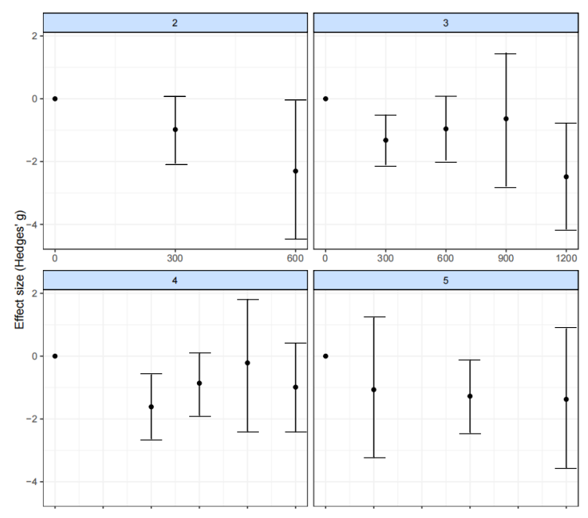
Appendix 13-2 “Split” NMA of different exercise agents.
Note: 2: Very light; 3: Light; 4: Moderate; 5: Vigorous.

2.Models selection
Appendix 13-3 Models fit comparison
Model | DIC | SD | Deviance | Residual deviance | pD
Emax (common treatment effects) | 535.6 | NA | 496.658 | 461.911 | 39.3
Restricted cubic spline (common treatment effects; 3 knots) | 434.8 | NA | 389.998 | 355.251 | 45.7
Restricted cubic spline (random treatment effects; 3 knots) | 171.7 | 0.165 (0.728, 1.367) | 104.701 | 69.954 | 67.7
Quadratic function (common treatment effects) | 558.2 | NA | 516.305 | 481.558 | 42.4
Quadratic function (random treatment effects) | 171.7 | 0.164 (0.812, 1.435) | 104.448 | 69.701 | 67.8
Non-parametric monotonically up (common treatment effects) | 1081 | NA | 1046.796 | 1012.049 | 34.9
For our data, quadratic model shows the best fit and were therefore used in subsequent analyses.

3. Deviation check
In addition to the model fit index, a deviation plot showing the contribution of each data point to the residuals can also help to confirm the robustness of the model selection. The contribution of each data point to the posterior mean bias should be around 1, which indicates a good model fit(Dias et al., 2013). Deviation plots for overall (Appendix 13-4) treatment effects (Appendix 13-5) confirm the robustness of our model selection (i.e., deviations <1.5).
Appendix 13-4 Deviance plot at overall exercise
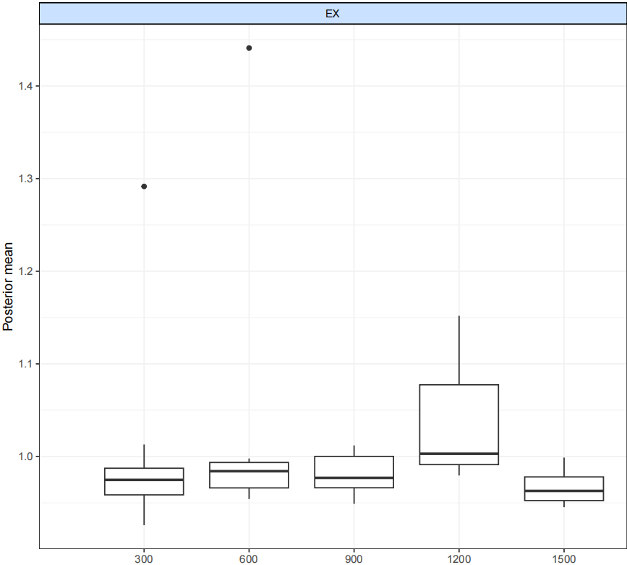

Appendix 13-5 Deviance plots at treatment-level
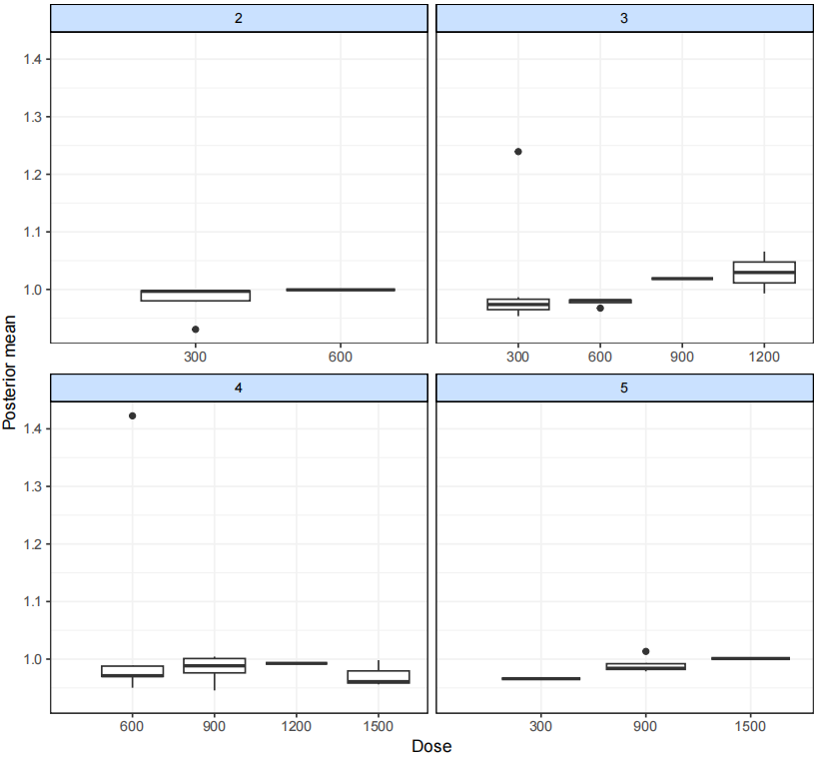
2: Very light; 3: Light; 4: Moderate; 5: Vigorous.

4.Degree of fit test
In addition, we also plotted the fit further to assess the degree of fit of the model. The fit values are plotted as connecting lines, and the observations in the original dataset are plotted as points. These plots can determine if the model fits the data well for different exercises and doses of the dose-response function(“Dose-response functions,” n.d.).

Appendix 13-6 Fit plots at overall exercise level.

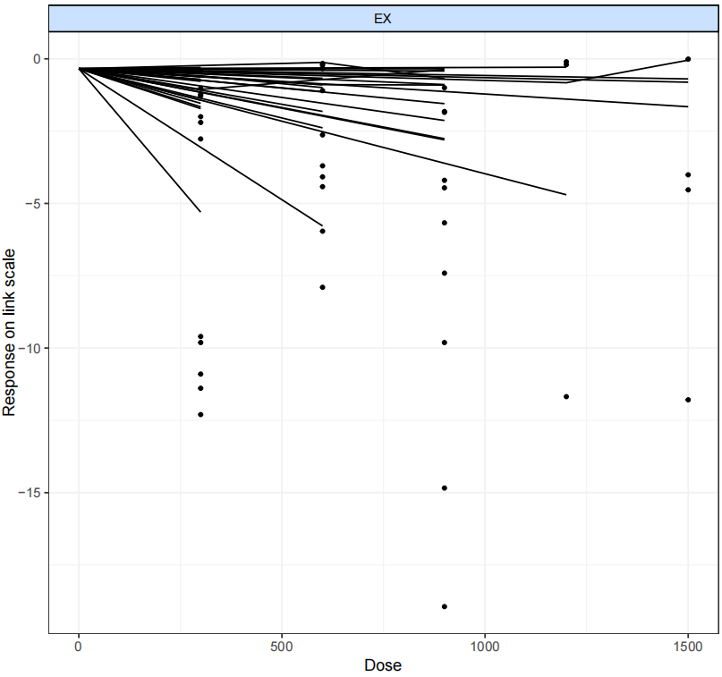
Appendix 13-7 Fit plots at agent-level.
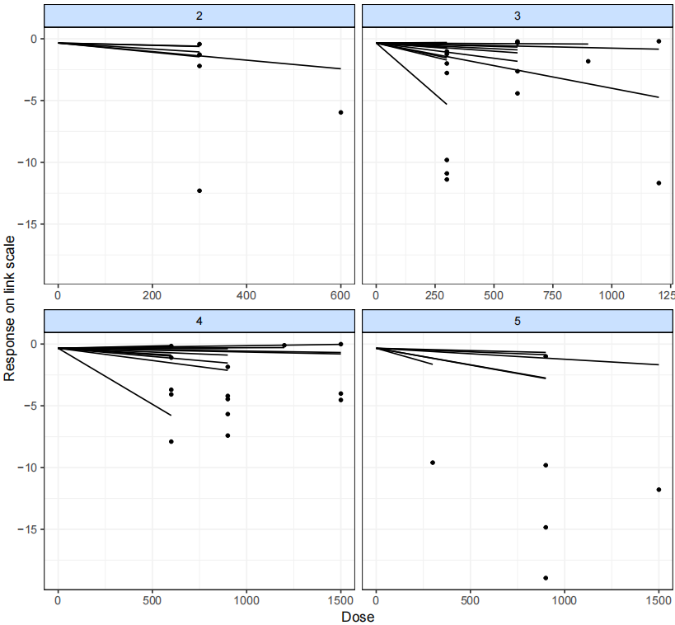
2: Very light; 3: Light; 4: Moderate; 5: Vigorous.

Appendix 14 Ranking the effects of different exercise intensities
Appendix 14 Sorting Chart of Effects of Different Exercise Intensities
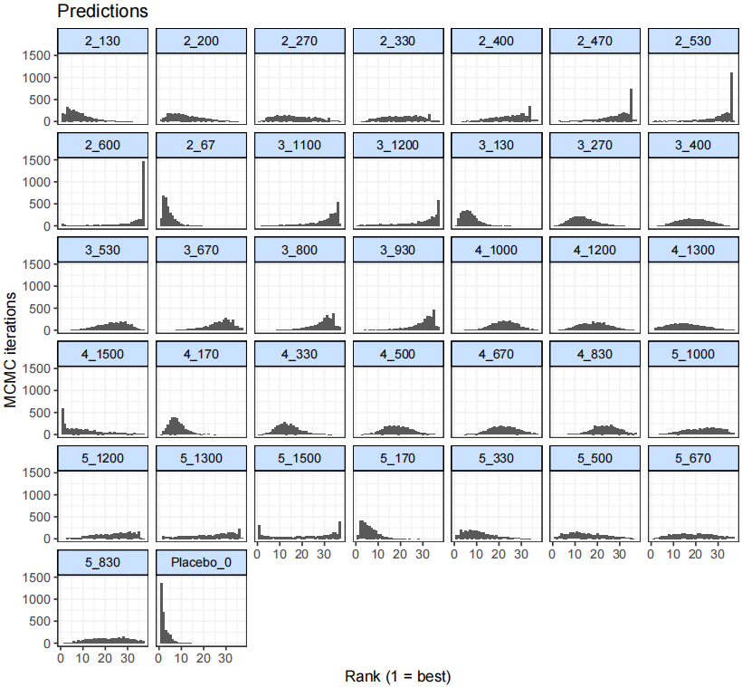
The first value indicates the specific intervention and the second one is the corresponding dose of that intervention (METs-min per week METs-min per week).
Placebo: control; 2: Very light; 3: Light; 4: Moderate; 5: Vigorous

Appendix 15 GRADE assessment
1. Summary of study limitations of the included studies.
The colours of the line indicate the summative ROB assessment of each comparison based on ROB assessment
of each included studies (low ROB comparison [green], moderate ROB comparison [yellow] and high ROB
comparison [red]).
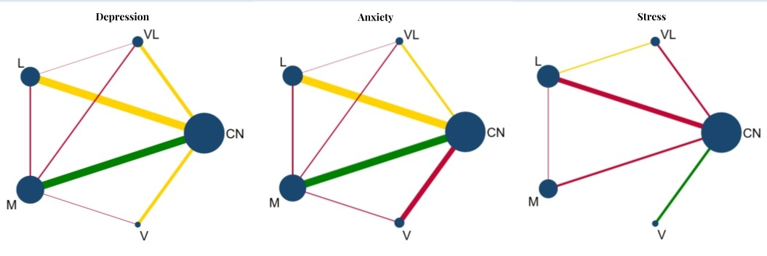
Appendix 15-1
CN- control, VL- very light, L- light, M- moderate，V- vigorous

2. Contribution of ROB comparisons to each network estimate.
Based on the above assessment of ROB for each comparison and the contributions of direct and indirect comparisons to all network estimates, the following bar graphs show the percentage of low, moderate and high ROB contributions for each network estimate.
Note: A-CON, B- very light, C- light, D- moderate，E- vigorous
Appendix 15-2 Depression
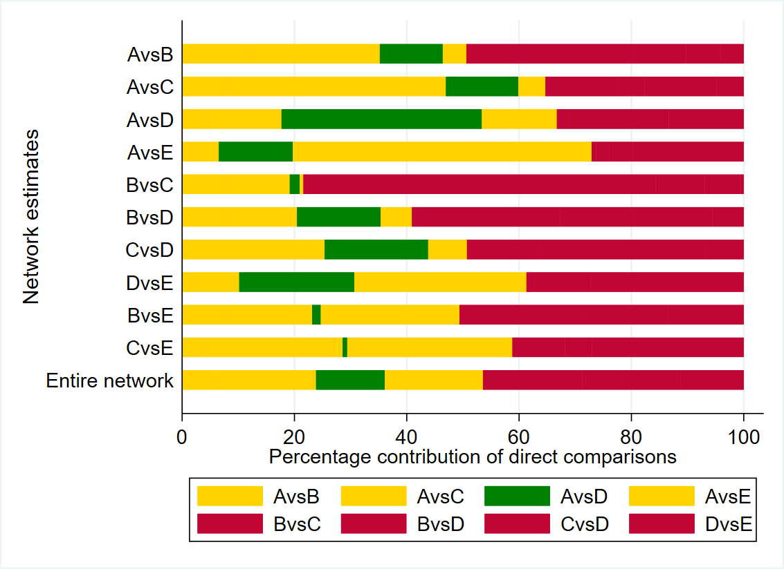

Appendix 15-3 Anxiety
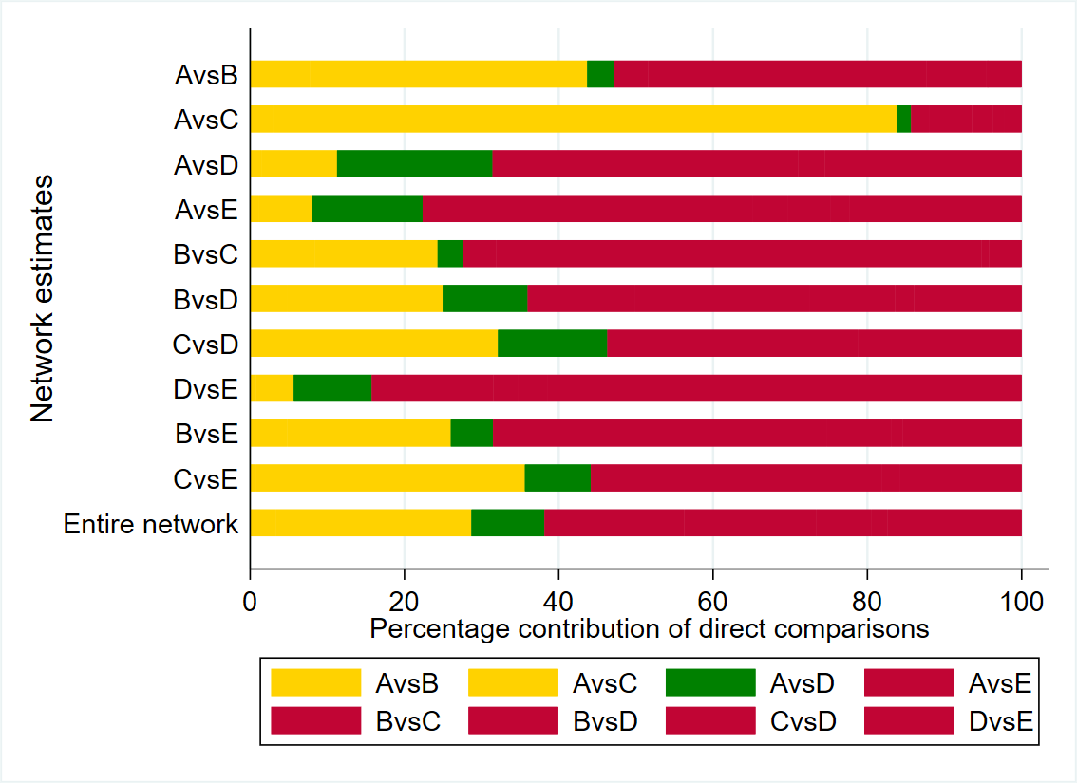

Appendix 15-4 Stress
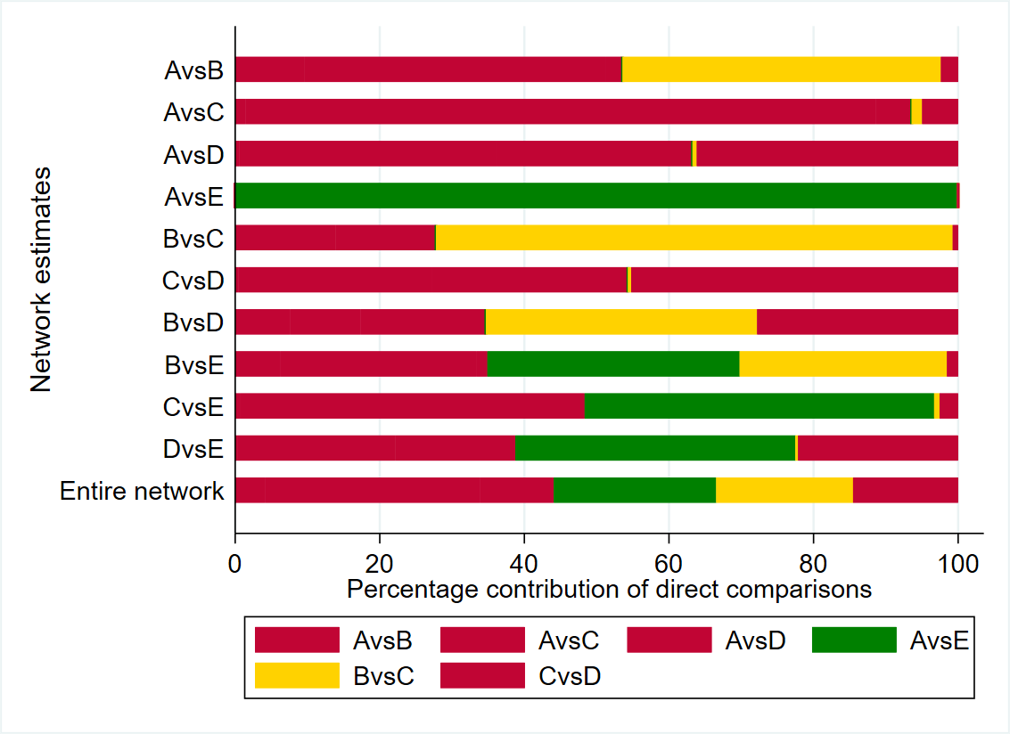

3.Table of reasons for downgrading.
Based on all the above information, we GRADE each network estimate according to the following criteria.
(1) Study limitations
Low risk (green)/unclear risk (yellow)/high risk (red) of each direct comparison was given a weight of 0/- 1/-2, respectively. And then the risk value of each comparison and SUCRA probability sorting result were calculated according to the contribution to ROB comparisons to each network estimate. It would be downgraded by one level when the risk value is between -1.5 and -0.6 (indicated by “Study limitations”) and two level when the risk value is less than -1.6 (indicated by “Study limitations²”).
(2) Indirectness
was assessed by determining whether the study population, type of intervention, and results were directly relevant to the purpose of this meta-analysis.
(3) Inconsistency
In this project, we examined heterogeneity and inconsistency. Heterogeneity between each pair of direct comparisons was evaluated by whether the prediction interval of the pairwise forest plots (Appendix 9) crossed the invalid line, it was judged as highly heterogeneous if crossed (indicated by “Heterogeneity”). Inconsistency between direct and indirect comparisons was evaluated by loop-specific heterogeneity estimates and node splitting analysis (indicated by “Inconsistency”). The stability of the SUCRA probability sorting result is evaluated according to global inconsistency.
(4) Imprecision
Imprecision was evaluated by appropriate sample sizes, a sample size below 400 would be downgraded by one level. The total sample size in this study was over 400, so this project was not downgraded. The Imprecision of the ranking results is evaluated according to the gap between the ranking values. If the gap between the ranking values of each treatment is small, which indicating a poor stability, the intervention would be downgraded by one leve.
(5) Publication bias
Using Begg's of pairwise meta-analysis, the intensity of the intervention with publication bias was reduced by one level, and the group compared to this intensity was also reduced by one level
Although the NMA comparison-adjusted funnel plot did not suggest presence of overall publication bias, it was subjective evaluation and we cannot completely rule out the possibility that some studies are still missing. Therefore, for the group directly compared with CON, the Begg’s test of pairwise meta-analysis was used to evaluate whether there was publication bias. Considering that the small sample size of groups compared with non-CON may lead to publication bias, all groups compared with non-CON were downgraded by one level.
Appendix 15-5 GRADE Rating Results for depression, anxiety, and stress
Depression
Comparison | Nature of the evidence | Confidence | Downgrading due to
AB | Mixed | Low | Study limitations, Heterogeneity
AC | Mixed | Very low | Study limitations, Heterogeneity,Publication bias
AD | Mixed | Very low | Study limitations,Heterogeneity,Publication bias
AE | Mixed | Low | Study limitations,Heterogeneity
BC | Mixed | Very low | Study limitations²,Publication bias
BD | Mixed | Low | Study limitations,Publication bias
CD | Mixed | Low | Study limitations,Publication bias
DE | Mixed | Low | Study limitations,Publication bias
BE | Indirect | Low | Indirectness,Publication bias
CE | Indirect | Low | Indirectness,Publication bias
Ranking of treatments |  | Moderate | Study limitations

Anxiety
Comparison | Nature of the evidence | Confidence | Downgrading due to
AB | Mixed | Moderate | Study limitations
AC | Mixed | Low | Study limitations,Heterogeneity
AD | Mixed | Low | Study limitations,Heterogeneity
AE | Mixed | Very low | Study limitations²,Heterogeneity
BC | Mixed | Low | Study limitations²
BD | Mixed | Low | Study limitations²
CD | Mixed | Moderate | Study limitations
DE | Mixed | Low | Study limitations²
BE | Indirect | Low | Indirectness,Publication bias
CE | Indirect | Low | Indirectness,Publication bias
Ranking of treatments |  | Low | Study limitations²

Stress
Comparison | Nature of the evidence | Confidence | Downgrading due to
AB | Mixed | Very low | Study limitations²,Heterogeneity
AC | Mixed | Very low | Study limitations²,Heterogeneity
AD | Mixed | Very low | Study limitations²,Heterogeneity,Publication bias
AE | Mixed | Moderate | Heterogeneity
BC | Mixed | Moderate | Study limitations
CD | Mixed | Very low | Study limitations²,Publication bias
BD | Indirect | Low | Indirectness,Publication bias
DE | Indirect | Low | Indirectness,Publication bias
BE | Indirect | Low | Indirectness,Publication bias
CE | Indirect | Low | Indirectness,Publication bias
Ranking of treatments |  | Moderate | Study limitations
References
Dias, Sutton, Ades, Welton, 2013. Evidence synthesis for decision making 2: a generalized linear modeling framework for pairwise and network meta-analysis of randomized controlled trials. Med Decis Making 33, 607–617.
Donegan, Williamson, D’Alessandro, Tudur Smith, 2013. Assessing key assumptions of network meta-analysis: a review of methods. Res Synth Methods 4, 291–323.
Dose-response functions, n.d.
Mawdsley, Bennetts, Dias, Boucher, Welton, 2016. Model-Based Network Meta-Analysis: A Framework for Evidence Synthesis of Clinical Trial Data. CPT Pharmacometrics Syst Pharmacol 5, 393–401.
Ter Veer, van Oijen, van Laarhoven, 2019. The Use of (Network) Meta-Analysis in Clinical Oncology. Front Oncol 9, 822.
van Valkenhoef, Dias, Ades, Welton, 2016. Automated generation of node-splitting models for assessment of inconsistency in network meta-analysis. Res Synth Methods 7, 80–93.
Watt, Tricco, Straus, Veroniki, Naglie, Drucker, 2019. Research Techniques Made Simple: Network Meta-Analysis. J Invest Dermatol 139, 4-12.e1.
Wheeler, Hickson, Waller, 2010. Assessing Local Model Adequacy in Bayesian Hierarchical Models Using the Partitioned Deviance Information Criterion. Comput Stat Data Anal 54, 1657–1671.

